**Statistics peter.asian.beetles**

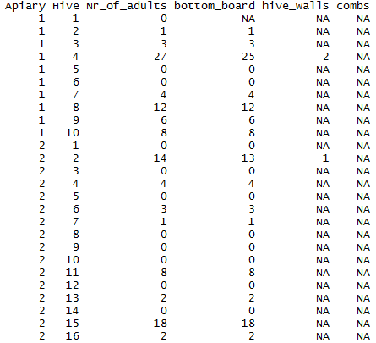

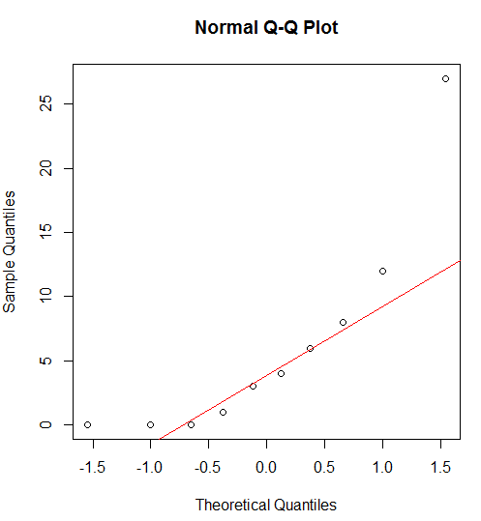**mean, quartil, range, and distribution number of beetles per apiary**

Apiary1:

* MEAN: 6.1
* MEDIAN: 3.5
* QUARTILES:
* MAX: 27
* MIN: 0
* 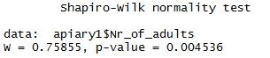RANGE: 27
* NORMALDISTRIBUTION: No

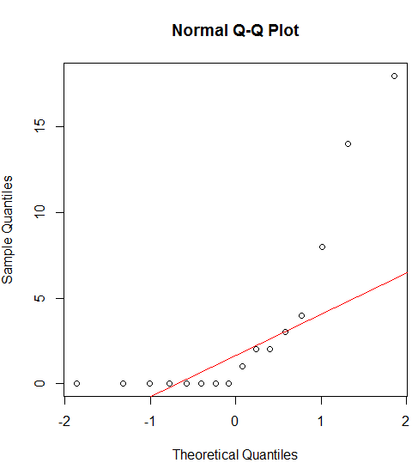

Apiary2:

* MEAN: 3.25
* MEDIAN: 0.5
* QUARTILES:
* MAX: 18
* MIN: 0
* RANGE: 18
* NORMALDISTRIBUTION: No 

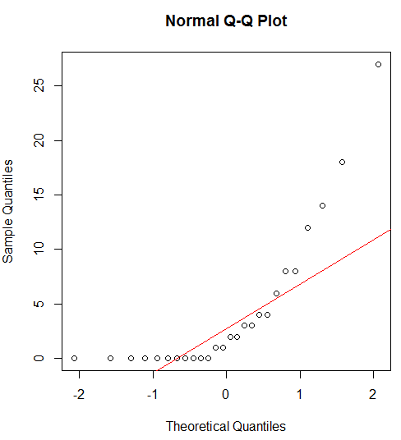

**mean, quartil, range, and distribution number of beetles for all hives**

* MEAN: 4.35
* MEDIAN: 1.5
* QUARTILES:
* MAX: 27
* MIN: 0
* 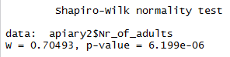RANGE: 27
* NORMALDISTRIBUTION: No